CSA47 – Deep Learning
Name: Thikkavarapu Sanhith Register No.: 19231

Experiment 3: Probability Distributions and Bayes’ Theorem
Question
Problem Statement: A diagnostic centre uses a screening test for a disease. Doctors need the probability that a patient with a positive result actually has the disease. Disease prevalence is 1%, test sensitivity 95% and specificity 90%. Patient age and test-score data follow known distributions. The objective is to model data with standard distributions and apply Bayes’ theorem to a real decision. Use NumPy, SciPy, Matplotlib.
Tasks:
- Generate and plot Bernoulli, Binomial, Poisson, Uniform and Gaussian samples with SciPy; compare with their PDFs/PMFs.
- Compute P(Disease | Positive) using Bayes’ theorem.
- Simulate 100,000 patients and verify the result empirically.
- Plot how the posterior changes as prevalence varies from 0.1% to 20%.
Code
"""Experiment 3: Probability Distributions and Bayes' Theorem"""
import numpy as np
import matplotlib.pyplot as plt
from scipy import stats

np.random.seed(42)
N = 10000

# ---- Task 1: distributions ----------------------------------------------
fig, ax = plt.subplots(2, 3, figsize=(14, 7))
ax = ax.ravel()

p = 0.3
s = stats.bernoulli.rvs(p, size=N)
ax[0].hist(s, bins=[-0.5, 0.5, 1.5], density=True, rwidth=0.5, alpha=0.6, label="samples")
ax[0].stem([0, 1], stats.bernoulli.pmf([0, 1], p), "r", label="PMF"); ax[0].set_title("Bernoulli(0.3)")

n = 20
s = stats.binom.rvs(n, p, size=N)
k = np.arange(0, n + 1)
ax[1].hist(s, bins=np.arange(-0.5, n + 1.5), density=True, alpha=0.6)
ax[1].plot(k, stats.binom.pmf(k, n, p), "ro-"); ax[1].set_title("Binomial(20, 0.3)")

lam = 4
s = stats.poisson.rvs(lam, size=N)
k = np.arange(0, 15)
ax[2].hist(s, bins=np.arange(-0.5, 15.5), density=True, alpha=0.6)
ax[2].plot(k, stats.poisson.pmf(k, lam), "ro-"); ax[2].set_title("Poisson(4)")

s = stats.uniform.rvs(0, 10, size=N)
x = np.linspace(-1, 11, 200)
ax[3].hist(s, bins=30, density=True, alpha=0.6)
ax[3].plot(x, stats.uniform.pdf(x, 0, 10), "r"); ax[3].set_title("Uniform(0, 10)")

s = stats.norm.rvs(50, 10, size=N) # e.g. patient age
x = np.linspace(10, 90, 200)
ax[4].hist(s, bins=40, density=True, alpha=0.6)
ax[4].plot(x, stats.norm.pdf(x, 50, 10), "r"); ax[4].set_title("Gaussian(50, 10)")
ax[5].axis("off")
plt.tight_layout(); plt.show()

# ---- Task 2: Bayes' theorem ---------------------------------------------
prev, sens, spec = 0.01, 0.95, 0.90

def posterior(prev, sens=sens, spec=spec):
p_pos = sens * prev + (1 - spec) * (1 - prev) # total probability
return sens * prev / p_pos

post = posterior(prev)
print(f"P(Disease | Positive) = {post:.4f} ({post*100:.2f}%)")

# ---- Task 3: simulation of 100,000 patients -----------------------------
M = 100_000
disease = np.random.rand(M) < prev
test_pos = np.where(disease, np.random.rand(M) < sens, np.random.rand(M) < (1 - spec))
emp = disease[test_pos].mean()
print(f"Positives: {test_pos.sum()}, of which diseased: {disease[test_pos].sum()}")
print(f"Empirical P(Disease | Positive) = {emp:.4f} vs theoretical {post:.4f}")

# ---- Task 4: posterior vs prevalence ------------------------------------
prevs = np.linspace(0.001, 0.20, 200)
plt.figure(figsize=(7, 4.5))
plt.plot(prevs * 100, posterior(prevs) * 100)
plt.scatter([1], [post * 100], color="red", zorder=3, label="1% prevalence")
plt.xlabel("Prevalence (%)"); plt.ylabel("P(Disease | Positive) (%)")
plt.title("Posterior vs prevalence"); plt.grid(alpha=0.3); plt.legend(); plt.show()

Output
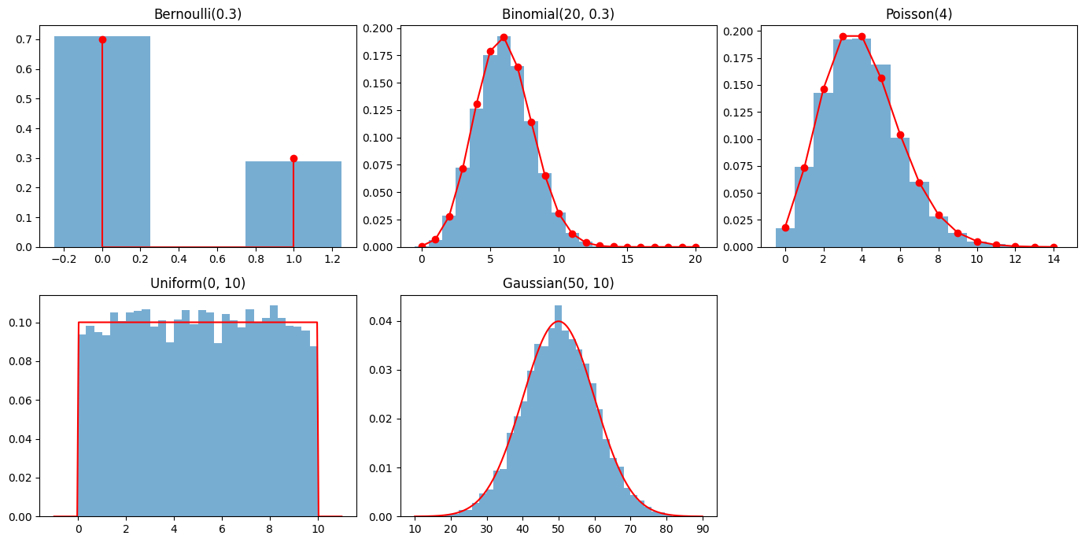
P(Disease | Positive) = 0.0876 (8.76%)
Positives: 10859, of which diseased: 932
Empirical P(Disease | Positive) = 0.0858 vs theoretical 0.0876
